**PROBLEM STATEMENT**

1. **KPI’s Requirement:**

We need to analyse the key indicators for our pizza sales data to gain insights into our business performance. Specifically we want to calculate the following metrics:

1. **Total Revenue**: The sum of the total price of all pizza orders.
2. **Average order value**: The average amount spent per order, calculated by dividing the total revenue by the total number of orders.
3. **Total pizzas sold**: The sum of the quantities of all pizzas sold.
4. **Total Orders**: The total numbers of orders placed.
5. **Average Pizzas per Order**: The average number of pizzas sold per order, calculated by dividing the total number of pizzas sold by the total number of orders.
6. **Calculate the total revenue from the dataset.**

SELECT sum(total_price) as total_revenue from pizza_sales

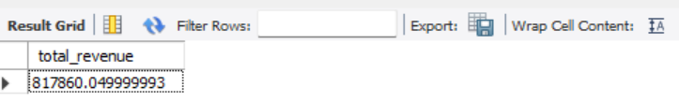

1. **Calculate the average order value from the dataset.**

select sum(total_price)/count(distinct order_id) from pizza_sales

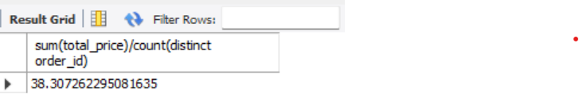

1. **Calculate the total pizza sold from the dataset.**

select sum(quantity) from pizza_sales

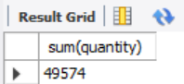

1. **Calculate the total order placed from the dataset.**

select count(DISTINCT order_id) from pizza_sales

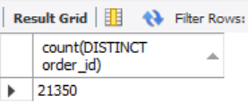

1. **Calculate the average pizzas per order placed from the dataset.**

select sum(quantity)/count(distinct order_id) from pizza_sales

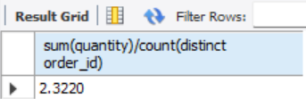

1. **Charts Requirement**

We would like to visualize various aspects of our pizza sales data to gain insights and understand key trends. We have identified the following requirement for creating charts:

1. **Daily trend for total orders:**

Create a bar chart that displays the daily trend of total orders over a specific time period. This chart will help us identify any patterns or fluctuations in order volumes on a daily basis.

1. **Percentage of sales by Pizza Category.**

SELECT pizza_category, sum (total_price)*100/ (SELECT sum (total_price) from pizza_sales)

from pizza_sales

GROUP BY pizza_category

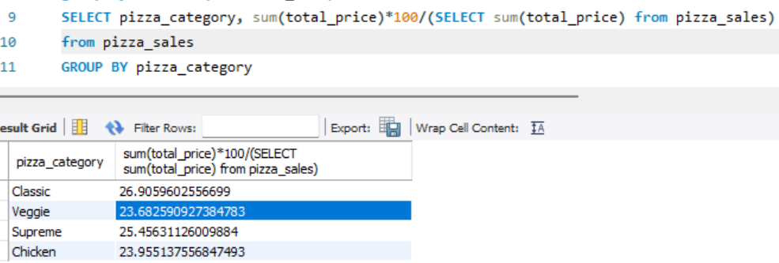

1. **Percentage of sales by pizza size.**

SELECT pizza_size, sum(total_price)*100/(SELECT sum(total_price) from pizza_sales)

from pizza_sales

GROUP BY pizza_size

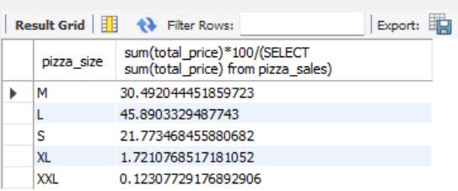

1. **Top 5 Best Sellers by Revenue. Total quantity and total orders.**

select pizza_name, sum(total_price) as total_revenue from pizza_sales

group by pizza_name

order by total_revenue desc

